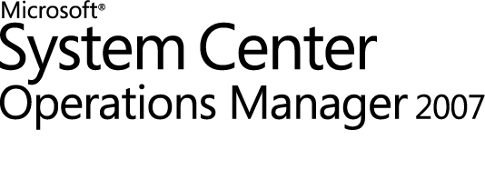

Windows Server 2008 Group Policy Management Pack Guide for Operations Manager 2007
Microsoft Corporation
Published: July 2009
Send suggestions and comments about this document to mpgfeed@microsoft.com. Please include the management pack guide name with your feedback.
Copyright
Information in this document, including URL and other Internet Web site references, is subject to change without notice. Unless otherwise noted, the companies, organizations, products, domain names, e-mail addresses, logos, people, places, and events depicted in examples herein are fictitious. No association with any real company, organization, product, domain name, e-mail address, logo, person, place, or event is intended or should be inferred. Complying with all applicable copyright laws is the responsibility of the user. Without limiting the rights under copyright, no part of this document may be reproduced, stored in or introduced into a retrieval system, or transmitted in any form or by any means (electronic, mechanical, photocopying, recording, or otherwise), or for any purpose, without the express written permission of Microsoft Corporation.
Microsoft may have patents, patent applications, trademarks, copyrights, or other intellectual property rights covering subject matter in this document. Except as expressly provided in any written license agreement from Microsoft, the furnishing of this document does not give you any license to these patents, trademarks, copyrights, or other intellectual property.
© 2009 Microsoft Corporation. All rights reserved.
Microsoft, MS-DOS, Windows, Windows Server, and Active Directory are either registered trademarks or trademarks of Microsoft Corporation in the United States and/or other countries.
All other trademarks are property of their respective owners.
Revision History

Release Date | Changes
May 2008 | Original release of this guide
July 2009 | Added “Changes in This Update”.

Contents
Introduction to the Windows Server 2008 Group Policy Management Pack for Operations Manager 2007 5
Changes in This Update 5
Supported Configurations 5
Getting Started 5
Before You Import the Management Pack 6
Files to Download 6
Other Requirements 6
How to Import the Windows Server 2008 Group Policy Management Pack 10
Create a New Management Pack for Customizations 11
Security Considerations 11
Low-Privilege Environments 11
Computer Groups 12
Understanding Management Pack Operations 12
Objects the Windows Server 2008 Group Policy Management Pack Discovers 12
Classes 14
How Health Rolls Up 16
Viewing Information in the Operations Manager Console 17
Key Monitoring Scenarios 17
Placing Monitored Objects in Maintenance Mode 17
Appendix: Monitors and Overrides for Management Packs 18
How to View Management Pack Details 18
How to Display Monitors for a Management Pack 18
How to Display Overrides for a Management Pack 18
How to Display All Management Pack Rules 19
How to Display Monitor Thresholds 19
How to Display Performance Collection Rules 21

Introduction to the Windows Server 2008 Group Policy Management Pack for Operations Manager 2007
The Windows Server 2008 Group Policy Management Pack includes monitors, rules, views, and knowledge for the monitoring of the application of group policy settings on Windows Server 2008. It provides a knowledge base of useful information to help administrators resolve an issue when group policy fails to process.
Document Version
This guide is based on the 6.0.6648.0 version of the Windows Server 2008 Group Policy Management Pack.
Getting the Latest Management Pack and Documentation
You can find the Windows Server 2008 Group Policy Management Pack in the System Center Operations Manager 2007 Catalog (http://go.microsoft.com/fwlink/?LinkId=82105).
Changes in This Update
The Group Policy Management Pack version 6.0.6648.0 includes the following change:
• Fixed an issue in which registry, script, and software installation errors and warnings were not reflected in the health state of a client.
Supported Configurations
The Windows Server 2008 Group Policy Management Pack is supported on operating systems running Windows Server 2008.

Getting Started
This section describes the actions you should take before you import the management pack and steps you should take after you import the management pack.
Before You Import the Management Pack
Before you import the Windows Server 2008 Group Policy Management Pack, note the following limitation of the management pack.
• There is no support for agentless monitoring.
• Only version 6.0.6278.22 or above of the Windows Server 2003 Group Policy Management Pack is compatible with the Windows Server 2008 Group Policy Management Pack.

Before you import the Windows Server 2008 Group Policy Management Pack, take the following action:
Delete the existing converted management pack for Group Policy 2008, if installed.
Files to Download
To monitor Group Policy, you must first download the Windows Server 2008 Group Policy Management Pack from the Management Pack Catalog, located at http://go.microsoft.com/fwlink/?LinkId=82105.
The Windows Server 2008 Group Policy Management Pack includes the following files:
• Microsoft.Windows.GroupPolicy.Library.mp
• Microsoft.Windows.GroupPolicy.2008.mp
Other Requirements
The following management packs must be installed prior to installing the Group Policy 2008 Management Pack:
• Windows Server Library Management Pack
• Windows Server 2008 Discovery Management Pack
The following management packs must be installed after installing the Group Policy 2008 Management Pack if you intend to manage Windows Server 2003 Group Policy:
• Windows Server 2003 Group Policy Management Pack, version 6.0.6278.22 or above
The following performance collection rules that are defined in the Windows Server Library Management Pack must be enabled or the Memory Utilization [Physical] dashboard view will be blank.
• Memory Pool Non-paged Bytes 2008
• Memory Pool Paged Bytes 2008

To enable these rules:
1. In System Center Operations Manager Operations console, click the Authoring button.
2. In the Authoring pane, click Rules, located in the top left area of the window.
3. Click the Change Scope link, which is blue and located in the navigation bar.

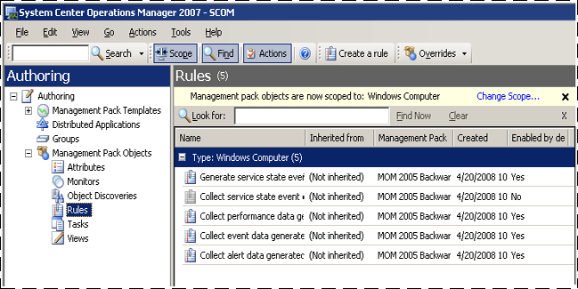

4. In the Scope Management Pack Objects by target(s) window, click the Clear All button that appears in the lower left corner of the window, and then type Windows Server 2008 Operating System in the Look for box.

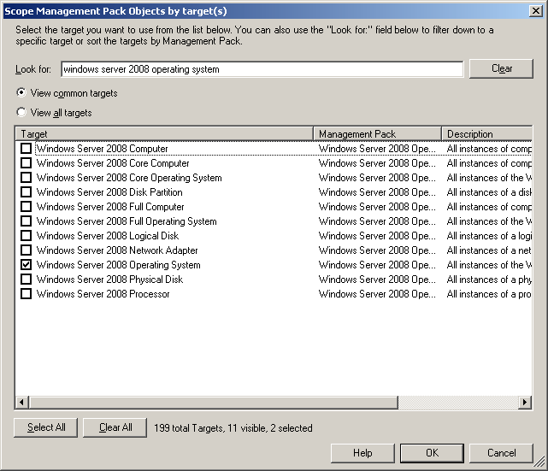

5. In the results pane, click Windows Server 2008 Operating System and the Scope Management Pack Objects by target(s) window closes.
6. In the Look for box, type paged.

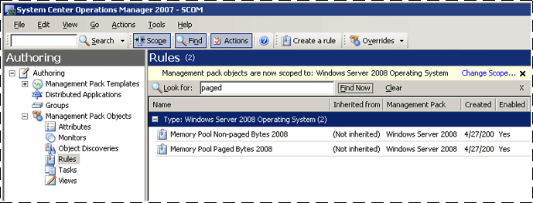

7. The System Center Operations Manager Operations console will automatically show rules with the word paged in the title (there are two results). These rules need to be enabled.
8. Right-click the first rule, Memory Pool Non-paged Bytes 2008, and then click Properties.
9. Select the Rule Is Enabled check box in the lower left area of the Memory Pool Non-paged Bytes 2008 Properties dialog box, and then click OK.

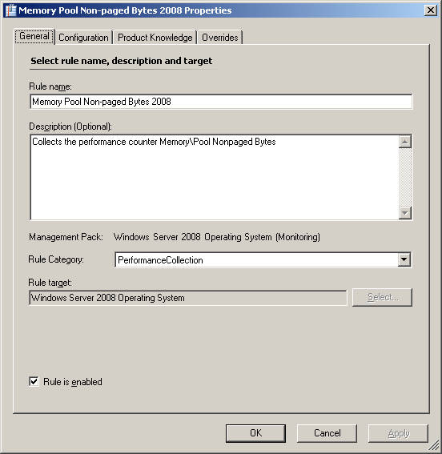

10. Repeat steps 9 and 10, but instead use the second rule, Memory Pool Paged Bytes 2008.
How to Import the Windows Server 2008 Group Policy Management Pack
For instructions about importing a management pack, see How to Import a Management Pack in Operations Manager 2007 (http://go.microsoft.com/fwlink/?LinkID=98348).

After the Windows Server 2008 Group Policy Management Pack is imported, follow this guideline to finish your initial configuration.
Create a new management pack in which you store overrides and other customizations.
Create a New Management Pack for Customizations
Most vendor management packs are sealed so that you cannot change any of the original settings in the management pack file. However, you can create customizations, such as overrides or new monitoring objects, and save them to a different management pack. By default, Operations Manager 2007 saves all customizations to the default management pack. As a best practice, you should instead create a separate management pack for each sealed management pack you want to customize.
Creating a new management pack for storing overrides has the following advantages:
• It simplifies the process of exporting to your production environment customizations that were created in your test and pre-production environments. For example, instead of exporting a default management pack that contains customizations from multiple management packs, you can export just the management pack that contains customizations of a single management pack.
• You can delete the original management pack without first needing to delete the default management pack. A management pack that contains customizations is dependent on the original management pack. This dependency requires you to delete the management pack with customizations before you can delete the original management pack. If all of your customizations are saved to the default management pack, you must delete the default management pack before you can delete an original management pack.
• It is easier to track and update customizations to individual management packs.
For more information about sealed and unsealed management packs, see Management Pack Formats (http://go.microsoft.com/fwlink/?LinkId=108355). For more information about management pack customizations and the default management pack, see About Management Packs in Operations Manager 2007 (http://go.microsoft.com/fwlink/?LinkId=108356).

Security Considerations
You may need to customize your management pack. Certain accounts cannot be run in a low-privilege environment or must have minimum permissions.
Low-Privilege Environments
The default action account must have the following permissions:

• System Event Log Read permission
• Performance Counters Read permission
Computer Groups
You can delegate authority to a precise level by using user roles. For more information about user roles, see the "About User Roles in Operations Manager 2007" topic in Operations Manager 2007 Help (http://go.microsoft.com/fwlink/?LinkId=108357).
The following computer groups can be used for scoping and roles authorization:
• Group Policy Client 2008 Computer Group
• Group Policy Client Computer Group

Understanding Management Pack Operations
The Windows Server 2008 Group Policy Management Pack monitors Group Policy infrastructure and in-scope client-side extensions.
Specifically, it provides Group Policy health monitoring for the following extensions:
• Group Policy core infrastructure/registry client-side extension
• Scripts client-side extension
• Software installation client-side extension
Objects the Windows Server 2008 Group Policy Management Pack Discovers
The Windows Server 2008 Group Policy Management Pack discovers the object types described in the following table.

Object type | Discovered automatically | Number of objects created | Description
Group Policy Client 2008 | Yes | 1 per server | Represents the Group Policy engine
Group Policy 2008 Registry Client-Side Extension | Yes | 1 per server | Represents the Group Policy registry component that enforces script execution
Group Policy 2008 Scripts Client-Side Extension | Yes | 1 per server | Represents the Group Policy scripts component that enforces script execution
Group Policy 2008 Software Installation Client-Side Extension | Yes | 1 per server | Represents the Group Policy installation component that enforces the installation policy
Group Policy Client 2008 Computers Group | Yes | 1 | Represents all Windows Server 2008 servers running Group Policy
Group Policy Client Computers Group | Yes | 1 | Represents all servers running Group Policy

For information about discovering objects, see the "Object Discoveries in Operations Manager 2007" topic in Operations Manager 2007 Help (http://go.microsoft.com/fwlink/?LinkId=108505).

To use an override to change the setting for automatic discovery:
1. In the Authoring pane, expand Management Pack Objects, and then click Object Discoveries.
2. On the Operations Manager toolbar, click Scope, and then filter the objects that appear in the details pane to include only Group Policy objects.
3. On the Operations Manager toolbar, use the Scope button to filter the list of objects, and then click Group Policy Agent Job.
4. On the Operations Manager toolbar, click Overrides, click Override the Object Discovery, and then click For all objects of type: Group Policy Agent, For a group.
5. In the Overrides Properties dialog box, click the Override box for the Enabled parameter.
6. Under Management Pack, click New to create an unsealed version of the management pack, and then click OK or select an existing management pack.
Note
By default, when you create a management pack object, disable a rule or monitor, or create an override, Operations Manager saves the setting to the Default Management Pack. As a best practice, you should create a separate management pack for each sealed management pack you want to customize, rather than saving your customized settings to the Default Management Pack.
After you change the override setting, the object type will be automatically discovered and will appear in the Monitoring pane under Group Policy.
Classes
The following diagram shows the classes defined in this management pack.

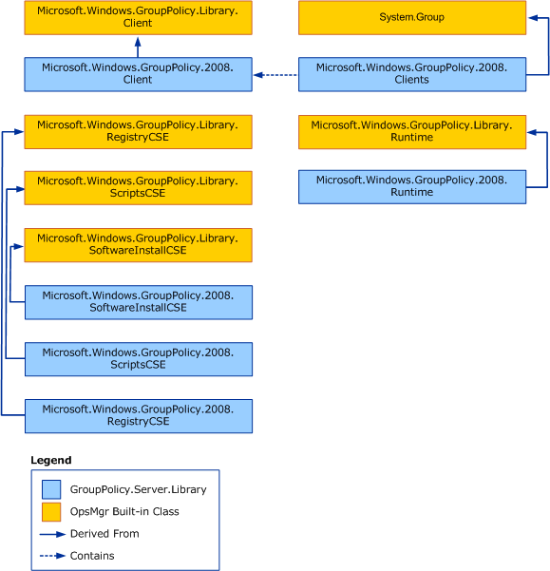

The following diagram shows the library classes defined in this management pack.

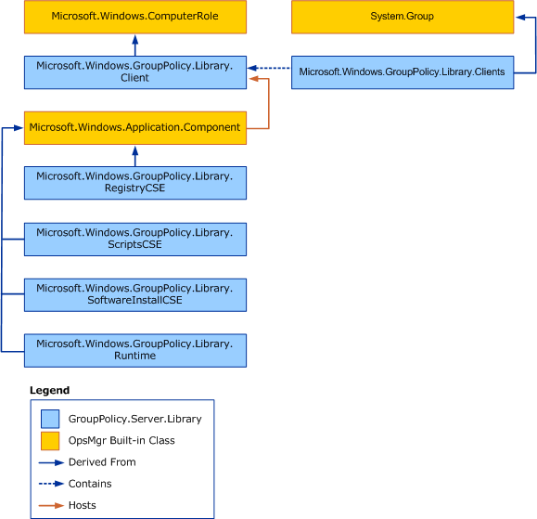

How Health Rolls Up
The following diagram shows how the health states of components roll up in this management pack.

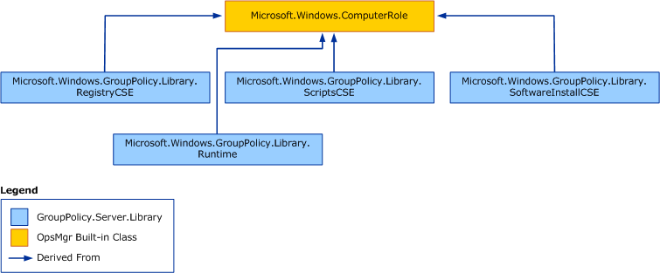

Viewing Information in the Operations Manager Console
All Windows Server 2008 Group Policy objects are contained in the Microsoft Windows Group Policy folder.
Key Monitoring Scenarios
The Windows Server 2008 Group Policy Management Pack includes a number of key monitoring scenarios that are configurable.
Some of the conditions monitored by this management pack are the following:
• Security permissions on sysvol that can prevent the reading of the management pack
• Application timeouts that can create connectivity problems that affect communication
• Registry policy application and/or enforcement failures
• Script policy application and/or enforcement failures
• Software installation application and/or enforcement failures
Placing Monitored Objects in Maintenance Mode
When a monitored object, such as a computer or distributed application, goes offline for maintenance, Operations Manager 2007 detects that no agent heartbeat is being received and, as a result, might generate numerous alerts and notifications. To prevent alerts and notifications, place the monitored object into maintenance mode. In maintenance mode, alerts, notifications, rules, monitors, automatic responses, state changes, and new alerts are suppressed at the agent.
For general instructions on placing a monitored object in maintenance mode, see How to Put a Monitored Object into Maintenance Mode in Operations Manager 2007 (http://go.microsoft.com/fwlink/?LinkId=108358).

Appendix: Monitors and Overrides for Management Packs
This section provides detailed procedures and scripts that you can use to display rules and other information about the management packs you import.
How to View Management Pack Details
For more information about a monitor and the associated override values, see the knowledge for the monitor.
To view knowledge for a monitor
1. In the Operations console, click the Authoring button.
2. Expand Management Pack Objects, and then click Monitors.
3. In the Monitors pane, expand the targets until you reach the monitor level. Alternatively, you can use the Search box to find a particular monitor.
4. Click the monitor, and in the Monitors pane, click View knowledge.
5. Click the Product Knowledge tab.

How to Display Monitors for a Management Pack
To display a list of outputs for a management pack's monitors and overrides using the command shell, use the following procedure.
To display monitors for a management pack
1. In the command shell, type the following command:
get-monitor -managementPack name.mp | export-csv filename
2. A .csv file is created. The .csv file can be opened in Microsoft Office Excel.
Note
In Excel, you may be required to specify that the .csv file is a text file.
For example, the following command retrieves data for the monitors associated with one of the core management packs:
get-monitor -managementPack System.Health.Library.mp | export-csv "C:\monitors.csv"
How to Display Overrides for a Management Pack
To display overrides for a management pack, use the following procedure.
To display overrides for a management pack
1. In the command shell, type the following command:
get-override -managementPack name.mp | export-csv filename
2. A .csv file is created. The .csv file can be opened in Excel.
Note
In Excel, you may be required to specify that the .csv file is a text file.
For example, this command displays the overrides for one of the core management packs:
get-override -managementPack Microsoft.SystemCenter.OperationsManager.Internal.mp | export-csv "c:\overrides.csv"
How to Display All Management Pack Rules
Use the following procedure to display a list of rules for the management packs that you imported. The list of rules can be viewed in Excel.
To display management pack rules
1. In your management server, click Programs, and then click System Center.
2. Click Command Shell.
3. In the Command Shell window, type the following command:
get-rule | select-object @{Name="MP";Expression={ foreach-object {$_.GetManagementPack().DisplayName }}},DisplayName | sort-object -property MP | export-csv "c:\rules.csv"
4. A .csv file is created. The .csv file can be opened in Excel.
Note
In Excel, you may be required to specify that the .csv file is a text file.

How to Display Monitor Thresholds
To display monitor thresholds, use the script described in this section. This script works for the majority of monitors. It creates a .csv file that includes the following columns and that can be viewed using Excel.

Column | Description
Type | The type of objects the monitor is targeted to
DisplayName | The display name of the monitor
Threshold | The threshold used by the monitor
AlertOnState | Determines whether the monitor generates an alert when the state changes
AutoResolveAlert | Determines whether the generated alert will be automatically resolved when the monitor state goes back to green
AlertSeverity | The severity of the generated alert

Run the following script to create the .csv file that displays the monitor thresholds:
function GetThreshold ([String] $configuration)
{
$config = [xml] ("<config>" + $configuration + "</config>")
$threshold = $config.Config.Threshold
if($threshold -eq $null)
{
$threshold = $config.Config.MemoryThreshold
}
if($threshold -eq $null)
{
$threshold = $config.Config.CPUPercentageThreshold
}
if($threshold -eq $null)
{
if($config.Config.Threshold1 -ne $null -and $config.Config.Threshold2 -ne $null)
{
$threshold = "first threshold is: " + $config.Config.Threshold1 + " second threshold is: " + $config.Config.Threshold2
}
}
if($threshold -eq $null)
{
if($config.Config.ThresholdWarnSec -ne $null -and $config.Config.ThresholdErrorSec -ne $null)
{
$threshold = "warning threshold is: " + $config.Config.ThresholdWarnSec + " error threshold is: " + $config.Config.ThresholdErrorSec
}
}
if($threshold -eq $null)
{
if($config.Config.LearningAndBaseliningSettings -ne $null)
{
$threshold = "no threshold (baseline monitor)"
}
}
return $threshold
}
$perfMonitors = get-monitor -Criteria:"IsUnitMonitor=1 and Category='PerformanceHealth'"
$perfMonitors | select-object @{name="Target";expression={foreach-object {(Get-MonitoringClass -Id:$_.Target.Id).DisplayName}}},DisplayName, @{name="Threshold";expression={foreach-object {GetThreshold $_.Configuration}}}, @{name="AlertOnState";expression={foreach-object {$_.AlertSettings.AlertOnState}}}, @{name="AutoResolveAlert";expression={foreach-object {$_.AlertSettings.AutoResolve}}}, @{name="AlertSeverity";expression={foreach-object {$_.AlertSettings.AlertSeverity}}} | sort Target, DisplayName | export-csv "c:\monitor_thresholds.csv"
How to Display Performance Collection Rules
To display performance collection rules, use the script in this section. This script works for the majority of monitors. It creates a .csv file that includes the following columns and that can be viewed using Excel.

Column | Description
WriteAction | Contains information about where the performance counter is written
WriteToDB or CollectionPerformanceData | Writes to the Operations Manager Operations database
WriteToDW or CollectPerfDataWarehouse | Writes to the data warehouse
WC | Stores baseline data for a performance counter in the Operations Manager Operations database

To display the performance collection rules present in the management group, run the following script:
function GetPerfCounterName ([String] $configuration)
{
$config = [xml] ("<config>" + $configuration + "</config>")
return ($config.Config.ObjectName + "\" + $config.Config.CounterName)
}
function GetFrequency ([String] $configuration)
{
$config = [xml] ("<config>" + $configuration + "</config>")
$frequency = $config.Config.Frequency;
if($frequency -eq $null)
{
$frequency = $config.Config.IntervalSeconds;
}
return ($frequency)
}
function GetDisplayName($performanceRule)
{
if($performanceRule.DisplayName -eq $null)
{
return ($performanceRule.Name);
}
else
{
return ($performanceRule.DisplayName);
}
}
function GetWriteActionNames($performanceRule)
{
$writeActions = "";
foreach($writeAction in $performanceRule.WriteActionCollection)
{
$writeActions += " " + $writeAction.Name;
}
return ($writeActions);
}
$perf_collection_rules = get-rule -criteria:"Category='PerformanceCollection'"
$perf_collection_rules | select-object @{name="Type";expression={foreach-object {(Get-MonitoringClass -id:$_.Target.Id).DisplayName}}},@{name="RuleDisplayName";expression={foreach-object {GetDisplayName $_}}} ,@{name="CounterName";expression={foreach-object {GetPerfCounterName $_.DataSourceCollection[0].Configuration}}},@{name="Frequency";expression={foreach-object {GetFrequency $_.DataSourceCollection[0].Configuration}}},@{name="WriteActions";expression={foreach-object {GetWriteActionNames $_}}} | sort Type,RuleDisplayName,CounterName | export-csv "c:\perf_collection_rules.csv"

